AI-Based Home Assistant Robot

Problem Statement:

Problem title:   
The need of modern world is to have a solution that not only keeps your home safe but also respects your privacy, can evolve with the latest technologies, and fits well into the dynamic lifestyles of today's households.

Problem Description:  
Current home security and automation systems lack the intelligence needed to keep up with the changing needs of modern households. They struggle with real-time monitoring, proactive security measures, and user-friendly communication. Basic features like facial recognition, abnormality detection, and integration with other smart home devices are often missing and if they are present they are not assembles in a single robot, they have to purchase it individually, that increases space occupancy and cost. Home owners are left without a comprehensive solution that ensures privacy, security, and adaptability in today's fast-paced technological environment. There's a clear need for an advanced system that leverages AI, robotics, and IoT to provide a smarter, more user-friendly home security and automation experience.

Our Solution:

An AI-Based Robot which will be helping and assisting for every day-to-day tasks in routine of house or work/office. It will be behaving friendly and will be giving you a support by interacting with you. In other words, it will become a companion in your life.

Important Features:  
- Privacy: Make sure that the personal information and activities within the home are kept private and secure from unauthorized access.  
- Security: Implement measures to protect the home from potential threats, such as intruders or unusual activities, ensuring the safety of residents and their belongings.  
- Adaptability: Create a system that can easily adjust to the changing needs of a modern household. This includes accommodating new technologies and adapting to different routines and preferences.

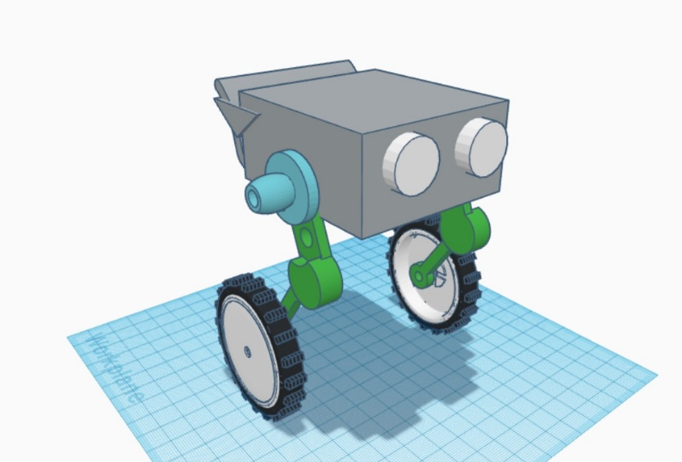

Challenges in Current Systems:

Lack of Intelligence: Current systems often lack the intelligence needed to adapt to the dynamic nature of modern households. They struggle with real-time monitoring and fail to proactively respond to security threats.

Fragmented Features: Basic features such as facial recognition, abnormality detection, and integration with other smart home devices are either absent or offered as separate components. This fragmented approach increases space occupancy and costs for homeowners.

User-Friendly Communication: Many existing systems fall short in providing user-friendly communication, making it challenging for homeowners to interact with and customize their security and automation settings.

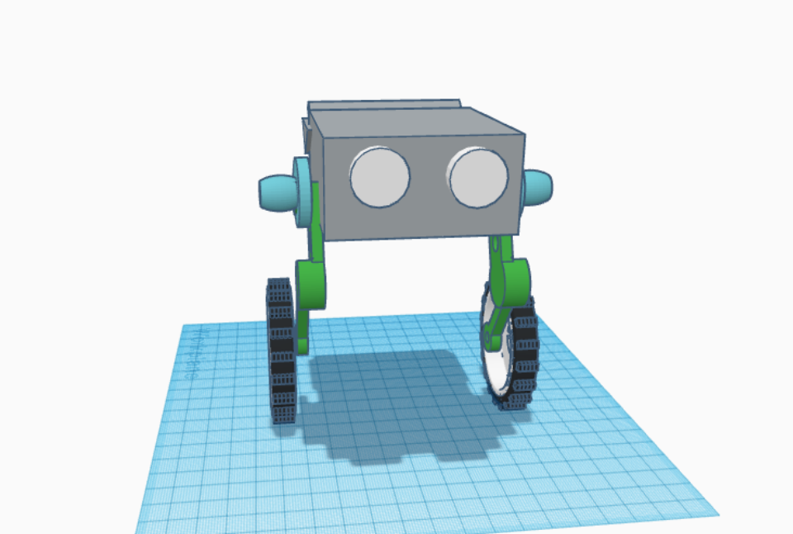

The development of an intelligent home security and automation robot aims to bridge the gaps in current systems. The robot will:

* Provide real-time monitoring with proactive security measures.
* Incorporate advanced features such as facial recognition and abnormality detection.
* Integrate seamlessly with various smart home devices into a single, compact unit.
* Prioritize user-friendly communication for easy interaction and customization.
* Guarantee privacy by implementing robust security protocols.

Benefits of the Proposed Solution:

* Holistic Security: The robot ensures a holistic approach to home security by combining advanced features in a single unit.
* Space and Cost Efficiency: By eliminating the need for separate components, the robot reduces space occupancy and overall costs for homeowners.
* User-Friendly Experience: With intuitive controls and interfaces, the robot offers a user-friendly experience for homeowners to manage their security and automation settings effortlessly.
* Adaptability and Future-Proofing: The robot's design allows for easy integration of new technologies, ensuring adaptability to future advancements in the smart home industry.

Features:

* Mobility
* Scan(Object/ Obstacle detection/Face recognition)
* Sensing(Temperature/humidity/Smoke/Gas/Fire)
* Emergency Alerts and calls.
* Mini Features: Clock, call, messaging, news, music, alarm, timer/reminders.
* Interactivity/ communication
* Constant dynamic learning
* Security/Surveillance: Abnormalities in routine(ex. Schedule, work pending), Unknown entity in house, Emergency calling – Security messages, patrolling.   
  Also it will do the surveillance for cleanliness, live video streaming.
* AI enabled model
* Smart Home Automation system
* Balanced, flexibility, compact, light-weighted.
* Companion to owner(Ideation).
* Data-Optimization and handling
* Entertainment(Jokes, music, fun ideas)
* Clicks picture(face detection)
* Optimization mode: Power-Saving Mode.

Required Components:

* Wifi Connection: ESP32
* Raspberry Pi
* Cooling Fan
* Battery
* Speaker, LED
* Charger
* Back-up battery
* 120 rpm DC motors
* Motor Driver – L298N
* DC-DC boost Step up converter
* DC-DC stepdown
* Gyroscope
* PCB
* Jumper(Suspension)
* Cables, wheels
* Camera
* Husky Lens
* Body(Case)
* Antenna
* Microphone
* Application(Software): Using information, components working information, location tracking.

We will be adding many more functionalities in future.